Problem Statement – Get an Email notification if any changes is done to your s3 bucket.

Prerequisite for the problem –

* AWS s3 bucket

Steps-

* AWS console-> services -> SNS.
* Topics -> Create New Topic.
* Give a topic name and topic display name.
* Now you have to update the policy so select the topic and click on action then again click on Edit topic policy.
* Go to advanced view and update your bucket name as shown in the given picture.

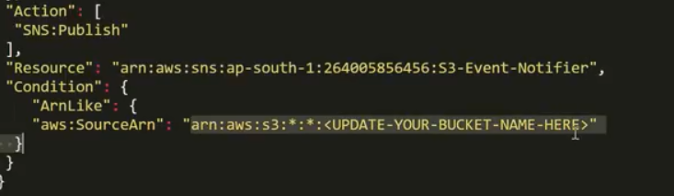

* Then you have to subscribe to the topic to get email notifications.
* Select the topic click on action then select create subscription.
* Select the protocol as Email (you can choice any one of them).
* In the endpoint section specify the email address you want to send.
* Go to the subscription you can see the subscription is in pending state so you need to accept the subscription from your mail id.
* Once you accept the subscription you can see subscription is conformed.
* AWS console -> services -> s3 -> click on your bucket.
* Go to properties then click on events.
* Create new events by clicking on Add notification.
* Then give name and select the events for which you want to be notified.
* On send to select SNS topic and add SNS topic notifier on SNS then click on save.
* Now you can get notification if any modification done to your bucket.